1. Create an html page to display the following nested list

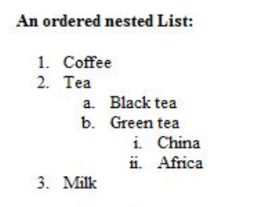

<html>

<head>

</head>

<body>

<b>An ordered nested List :</b>

<ol>

<li>Coffee</li>

<li>Tea</li>

<ol TYPE="a">

<li>Black tea</li>

<li>Green tea</li>

<ol TYPE="i">

<li>China</li>

<li>Africa</li>

</ol>

</ol>

<li>Milk</li>

</body>

</html>

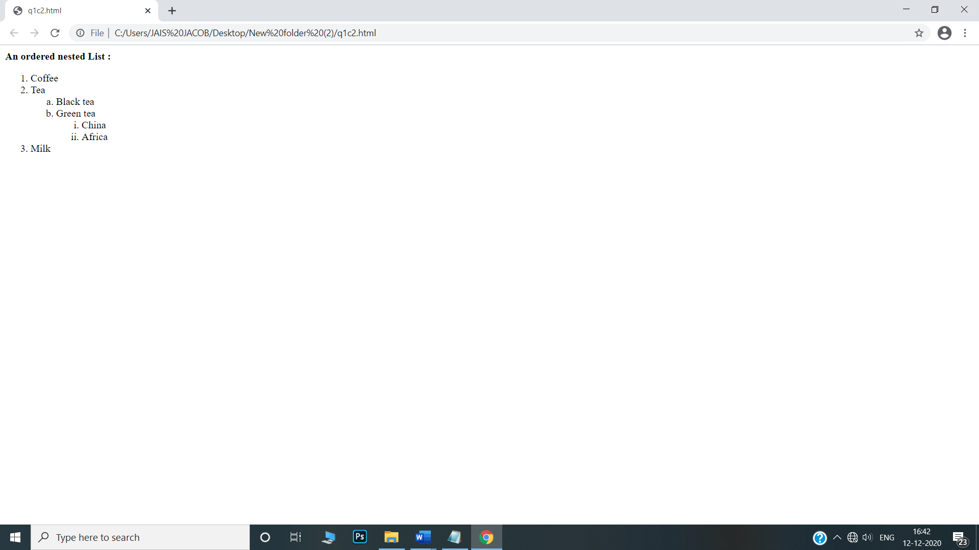

2. Create links to three different pages on three different websites that should all open in a new window

<html>

<head>

</head>

<body>

<br><br>

<a href="http://web.sjcetpalai.ac.in/" target="_blank">

<button>SJCET</button></a>

<br><br>

<a href="https://www.sgcaruvithura.ac.in/" target="_blank">

<button>SGC</button></a>

<br><br>

<a href="https://mvd.kerala.gov.in/" target="_blank">

<button>MVD</button></a>

</body>

</html>

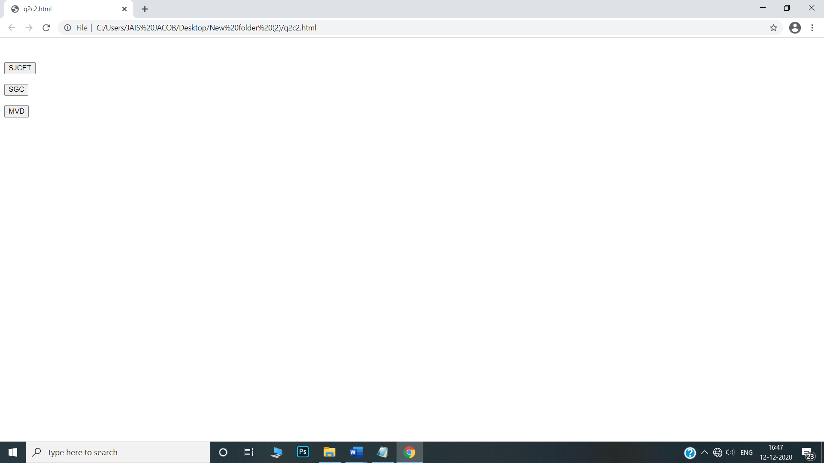

3. Create a page with a link at the top of it that when clicked will jump all the way to the bottom of the page.

<html>

<head>

</head>

<body>

<a href="#bottom">Click here to jump to the bottom of the page.</a>

<br>

1<br>

2<br>

3<br>

4<br>

5<br>

6<br>

7<br>

8<br>

9<br>

10<br>

11<br>

12<br>

13<br>

14<br>

15<br>

16<br>

17<br>

18<br>

19<br>

20<br>

21<br>

22<br>

23<br>

24<br>

25<br>

26<br>

27<br>

28<br>

29<br>

30<br>

<a name="bottom">The bottom of the page.</a>

</body>

</html>

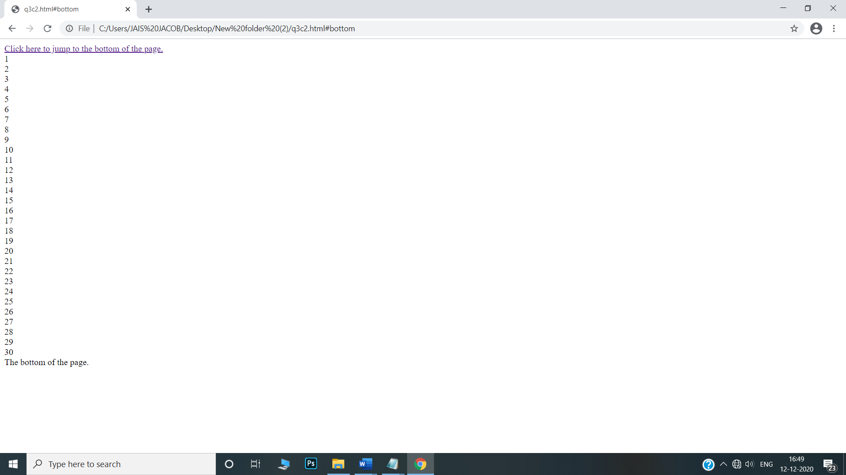

4. Display three different images. Skip two lines between each image. Each image should have a heading.

<html>

<head>

<body>

<br><br>

<h1>fan</h1>

<img src="D:\fan.jpg" alt="fan" title="fan"/>

<br><br>

<h1>leaf</h1>

<img src="D:\leaf.jpg" alt="leaf" title="leaf"/>

<br><br>

<h1>apple</h1>

<img src="D:\apple.jpg" alt="apple" title="apple"/>

</body>

</html>

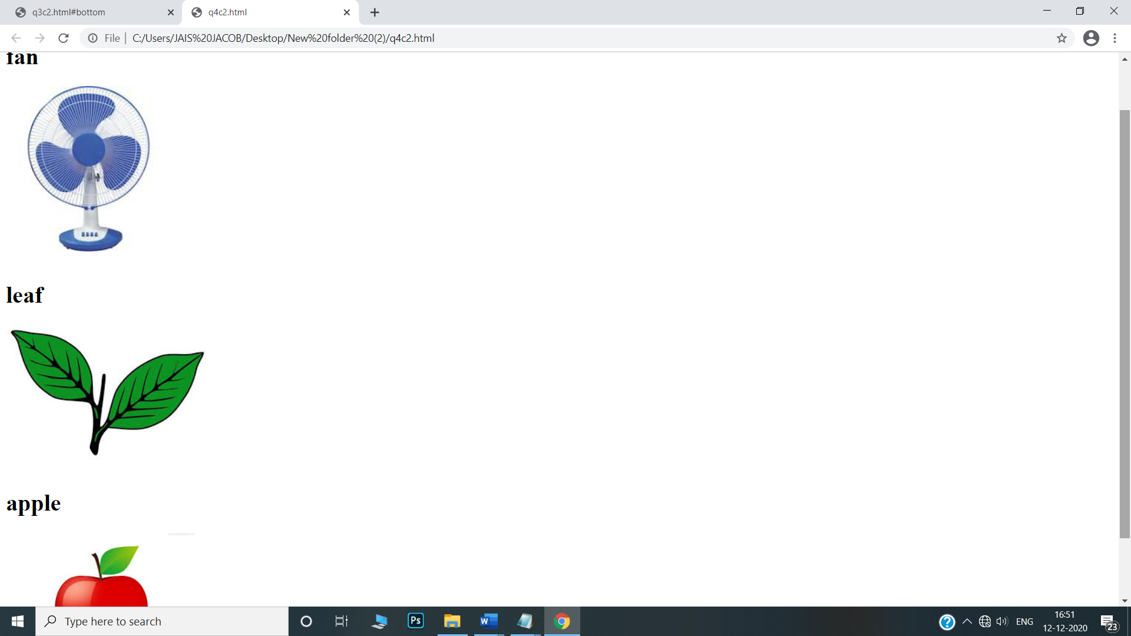

5. Display an image that when clicked will link to a search engine of your choice in a different window

<html>

<head>

</head>

<body>

<br><br>

<center>

<a href="https://www.youtube.com/" target="_blank">

<img src="D:\youtube.png" alt="youtube"/>

</a>

<p>click in the image to load youtube.</p>

</center>

</body>

</html>

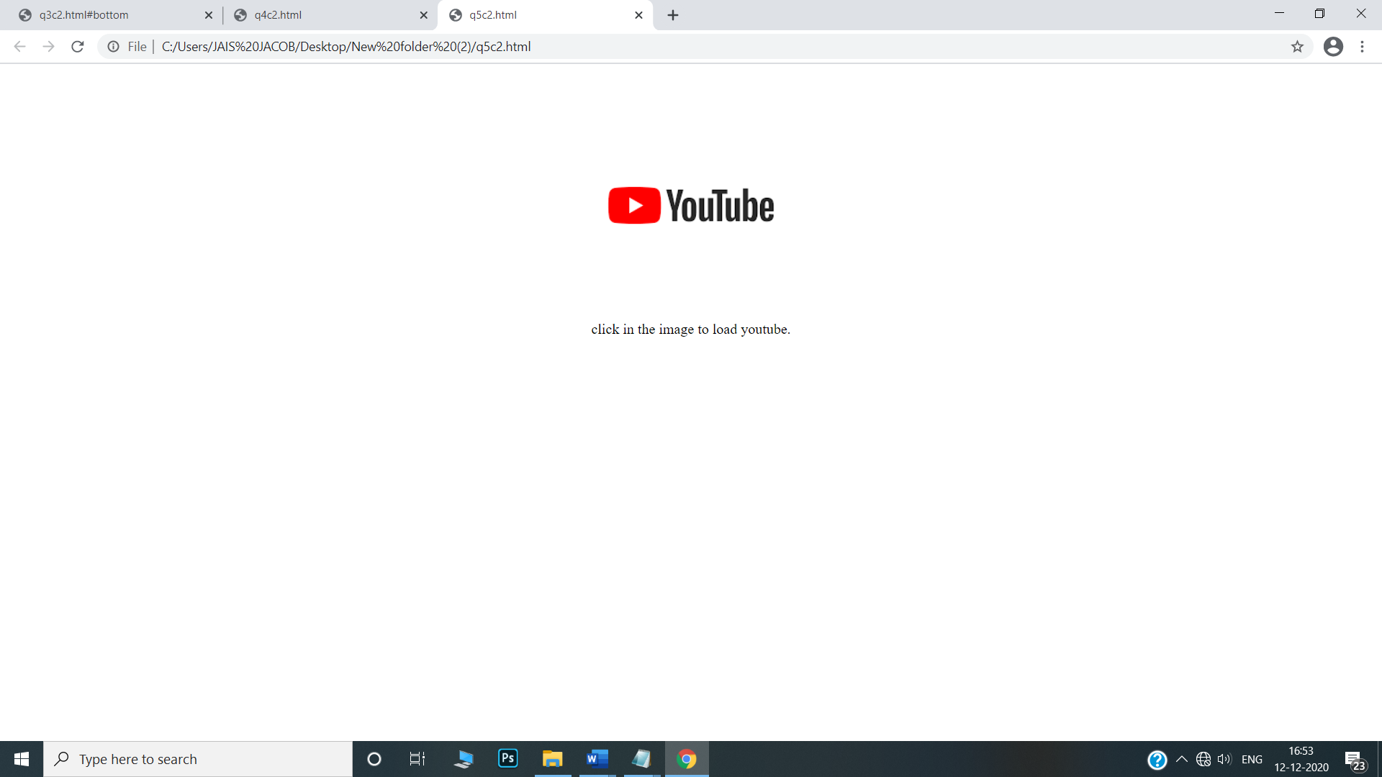

6.Create the following Html Page using appropriate form controls

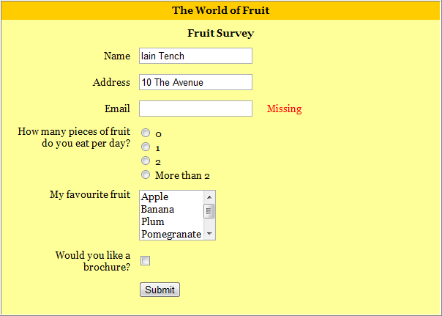

html>

<head>

<style>

.div_1{ background-color:orange; margin:10px; }

.div_2{ background-color:yellow; margin:10px; }

</style>

</head>

<body>

<center>

<div class="div_2">

<div class="div_1"><font size="4" face="Cooper"><h1>The World of Fruit</h1></font></div>

<form method="post">

<font size="4" face="Cooper"><h1 align="center" >Fruit Survey</h1></font>

<table align="center" cellpadding ="20" >

<tr>

<th>Name</th>

<td><input type="text" name="name" style="width:400px;" class="form-control" required=""></td>

</tr>

<tr>

<th>Address</th>

<td><input type="text" name="address" style="width:400px;" class="form-control" required=""></td>

</tr>

<tr>

<th>Email</th>

<td><input type="text" name="address" style="width:400px;" class="form-control" required=""></td>

<td><label style="color:red;"><b>Missing</b></label></td>

</tr>

<tr>

<th>How many pieces of fruit<br>do you eat per day?</th>

<td><input type="radio" name="0" value="0" >0<br><input type="radio" name="1" value="1">1<br><input type="radio" name="2" value="2" >2<br><input type="radio" name="More than 2" value="More than 2">More than 2</td>

</tr>

<tr>

<th>My favorite fruit</th>

<td><textarea rows="4" cols="12" name="favorite fruit">Apple Banana Plum Pomegranate Orange </textarea>

</td>

</tr>

<tr>

<th>Would you like a<br>brochure?</th>

<td><input type="checkbox" name="yes" value="on"></td>

</tr>

<tr>

<td align="center" colspan="2"><input type="submit" name="submit" value="submit"></td>

</tr>

</table>

</form>

</div>

</center>

</body>

</html>

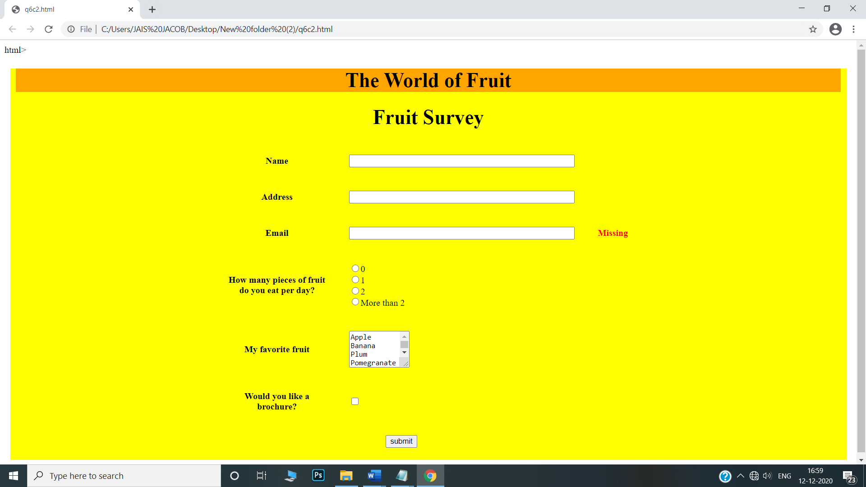

7. Create an image map for ‘Kerala Map’. Map at least 3 districts so that when you click on that particular district the details regarding that district(**eg: population, Area, Tourist Spots(with images), Monuments, Interesting Facts )** should be displayed on a new page.

<head>

</head>

<body>

<center>

<h1><u><font color="grey" face="Cooper">KERALA MAP</font></u></h1>

<map name="kerala">

<area shape="circle" coords="68,41,10" href="kannur.html"/>

<area shape="circle" coords="115,100,10" href="palakad.html"/>

<area shape="circle" coords="123,162,10" href="kottayam.html"/>

</map>

<img src="D:\kerala1.jpg" alt="kerala" usemap="#kerala"/>

</center>

</body>

</html>

<html>

<head>

<style>

.div_1{ background-color:blue; margin:20px; }

.div_2{ background-color:green; margin:20px; }

</style>

</head>

<body>

<center>

<br>

<div class="div_1"><h1><font color="white" size="6" face="Cooper">KANNUR</font></h1></div>

<div class="div_2"><font color="red" face="Comic sans MS">

<p>Kannur is a district in the Indian state of Kerala. The city of kannur is the district headquarters and gives the district its name. The district was established in 1957.</p>

<h1><u>HISTORY OF KANNUR</u></h1>

<p>Kannur was an important trading centre in the 12th century, with active business connections with Persia and Arabia. It served as the British military headquarters on India's west coast until 1887. The modern town is referred to as Kannur Town. Kannur, as a district and surrounding areas, were mostly ruled by the famous Kolathiri Rajas (Kings). When the state of Kerala was formed the district took the name Kannur since the administrative offices were established here. Before that, Kannur was under the Chirakkal taluk of Madras state under British rule. When the British dominated this part of the world, they preferred Madras and Cochin as their major stations and Kannur started to lose its old glory.</p>

<h1><u>CLIMATE</u></h1>

<p>Kannur has an elevation of 1.02 metres (2.98 ft) along the coast of the Laccadive Sea, with a sandy coastal area. The town has an 8 km-long seashore and a 3 km-long beach at Payyambalam.

Kannur experiences a rare humid tropical monsoon climate under the Köppen climate classification (Am). In the months of April and May, the average daily maximum temperature is about 35 °C (95 °F). Temperatures are moderate in December and January: about 24 °C (75 °F). Like other areas on the Malabar Coast, this town receives heavy rainfall during the Southwest monsoon. The annual average rainfall is 3438 mm, around 68% of which is received in summer.[14]</p>

<h1><u>TOURIST SPOTS IN KANNUR</u></h1>

<h2>Palakkayam Thattu</h2>

<img src="D:\KANNUR1.jpg" alt="palakkayam thattu" height="260" width="525"/>

<p>Palakkayam Thattu is one of the alluring places to visit in Kannur near the Western Ghats because of the verdant greenery and dizzying height of about 3350 feet above the sea level. </p>

<h2>Payyambalam Beach</h2>

<img src="D:\KANNUR2.jpg" alt="payyambalam" height="260" width="525"/>

<p>The Payyambalam Beach is considered as one of the unspoiled beaches in Kerala, adorned with golden sand and foamy white waters of the Arabian Sea. With its peaceful and inviting aura, the Payyambalam beach is an ideal destination for visitors to spend a long holiday.

You can literally unwind and rejuvenate yourself amidst the palm trees a</p>

</div>

</body>

</html>

<html>

<head>

<style>

.div_1{ background-color:red; margin:20px; }

.div_2{ background-color:yellow; margin:20px; }

</style>

</head>

<body>

<center>

<br>

<div class="div_1"><h1><font color="white" size="6" face="Cooper">PALAKKAD</font></h1></div>

<div class="div_2"><font color="green" face="Comic sans MS">

<p>Palakkad District, in the southeastern part of the former Malabar district, is one of the 14 districts of the South Indian state of Kerala. It is located right at the central part of the state. Also, it is the largest district in Kerala from 2006. The city of Palakkad is the district headquarters. Palakkad is bordered on the northwest by the Malappuram District, on the southwest by the Thrissur District, on the northeast by The Nilgiris District, and on the east by Coimbatore district of Tamil Nadu. </p>

<h1><u>HISTORY OF PALAKKAD</u></h1>

<p>Palakkad is the gateway to Kerala due to the presence of the Palakkad Gap, in the Western Ghats. The total area of the district is 4,480 km2 (1,730 sq mi) which is 11.5% of the state's area which makes it the largest district of Kerala. Out of the total area of 4,480 km2 (1,730 sq mi), about 1,360 km2 (530 sq mi) of land is covered by forests. </p>

<h1><u>CLIMATE</u></h1>

<p> The climate is pleasant for most parts of the year, the exception is the summer months. There is sufficient rainfall and it receives more rainfall than the extreme southern districts of Kerala. The district is blessed with many small and medium rivers, which are tributaries of the Bharathapuzha River.</p>

<h1><u>TOURIST SPOTS IN PALAKKAD</u></h1>

<h2>Parambikulam Tiger Reserve</h2>

<img src="D:\palakkad1.jpg" alt="parambikulam" height="260" width="525"/>

<p>Blooming with in rare varieties of medicinal plants, orchids and fauna, the Parambikkulam Wildlife Sanctuary is hailed to be one of the best wildlife sanctuaries in South India.</p>

<h2>Silent Valley National Park</h2>

<img src="D:\palakkad2.jpg" alt="silent valley" height="260" width="525"/>

<p> The Silent Valley National Park, with its lush green forests and beautiful views of the rich flora, is a popular destination for nature and wildlife lovers in Kerala. With its long, detailed history and the unique status of a Rain Forest, this national park is truly a sight to visit. The well-planned Safari and the beautiful stop-overs around the park only make a trip to this part of Kerala more worthwhile.</p>

</div>

</center>

</body>

</html>

<html>

<head>

<style>

.div_1{ background-color:blue; margin:20px; }

.div_2{ background-color:green; margin:20px; }

</style>

</head>

<body>

<center>

<br>

<div class="div_1"><h1><font color="white" size="6" face="Cooper">KOTTAYAM</font></h1></div>

<div class="div_2"><font color="red" face="Comic sans MS">

<p>Kottayam is a city in the Indian state of Kerala.[1] Kottayam literally means the interior of a fort—Kotta + Akam.[2] Flanked by the Western Ghats on the east and the Vembanad Lake and paddy fields of Kuttanad on the west, Kottayam is a place that is known for extraordinary qualities.[3] It is the district headquarters of Kottayam district, located in south-west Kerala. Kottayam is located in the basin of the Meenachil River at an average elevation of 3 metres (9.8 ft) above sea level, and has a moderate climate. It is located 150 kilometres (93 mi) north of the state capital Thiruvananthapuram.</p>

<h1><u>HISTORY OF KOTTAYAM</u></h1>

<p>The city is known for its trade in natural rubber, and the national Rubber Board is headquartered in the city, as is the Plantation Corporation of Kerala. Kottayam Port is India's first multi-modal inland container depot. The headquarters of the Malankara Orthodox Syrian Church, called the Catholicate Aramana (Catholicate palace), is situated at nearby Devalokam.[not verified in body]</p>

<h1><u>CLIMATE</u></h1>

<p>he climate in this district is moderate and pleasant. Kottayam's proximity to the equator results in little seasonal temperature variation, with moderate to high levels of humidity. Annual temperatures range between 20 and 35 °C (68 and 95 °F).[citation needed] From June through September, the south-west monsoon brings in heavy rains, as Kottayam lies on the windward side of the Western Ghats. From October to December, Kottayam receives light rain from the northeast monsoon. The average annual rainfall is around 3,000 millimetres (120 in).</p>

<h1><u>TOURIST SPOTS IN KOTTAYAM</u></h1>

<h2>Kottathavalam</h2>

<img src="D:\KOTTAYAM1.jpg" alt="KOTTATHAVALAM" height="260" width="525"/>

<p> A fascinating cave carved out of rock surface is Kottathavalam lying on the top of a Murugan Hills at Kurisumala. The cave is considered to be the resting place for Madura Royal family.

The cave is adorned with various sculptures of Gods and Goddesses along with the sculptures of weapons used in the ancient times giving us a glance into the amazing past.</p>

<h2> Nadukani</h2>

<img src="D:\KOTTAYAM2.jpg" alt="NADUKANI" height="260" width="525"/>

<p> After all the blessings from temples, it is time for some adventure. Nadukani is one such place nestled amid the wilderness of nature and densely wooded hills offering its visitors a beautiful trail for trekking.</p>

</div>

</center>

</body>

</html>

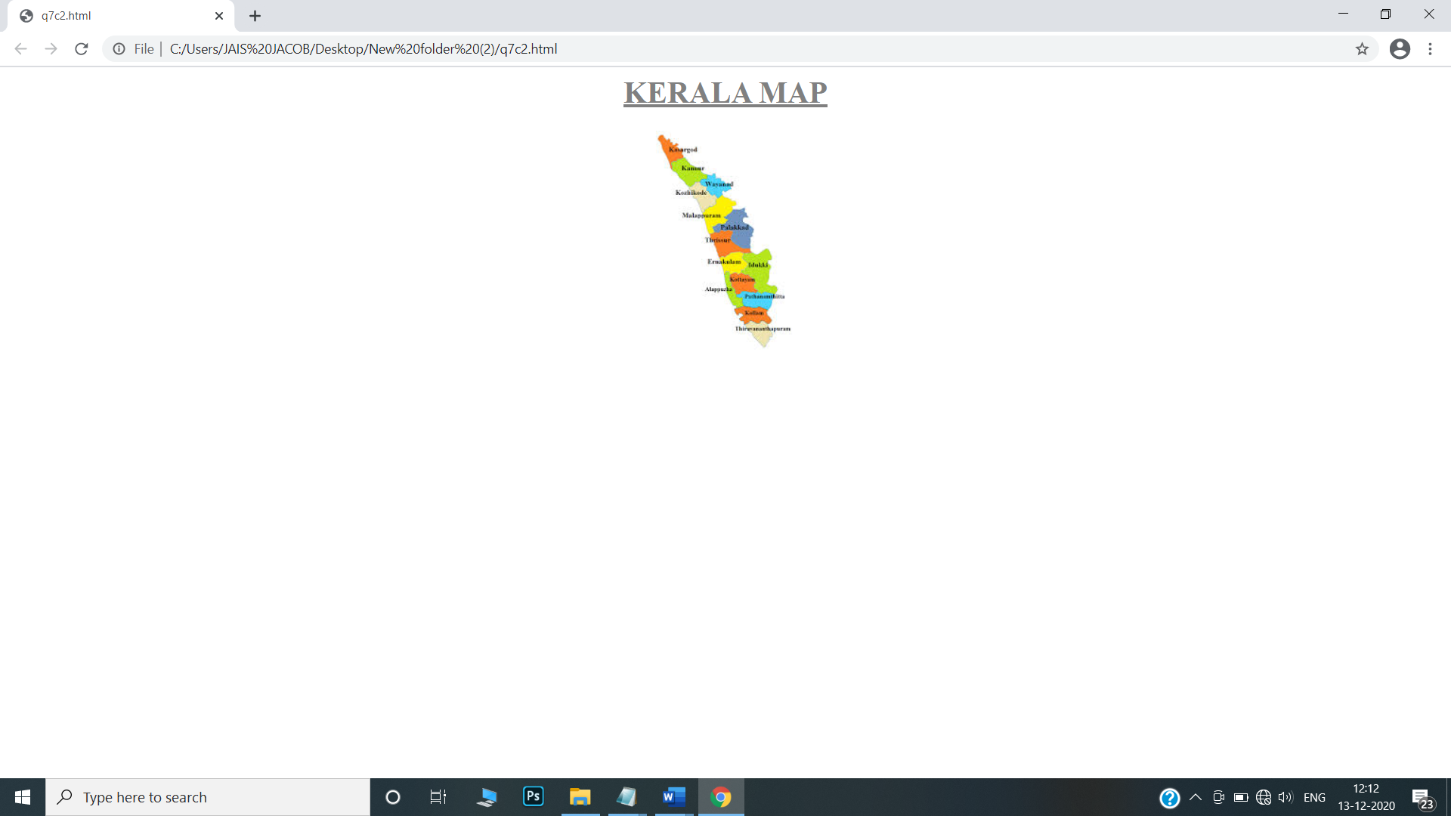

8. Construct this puzzle looking thing

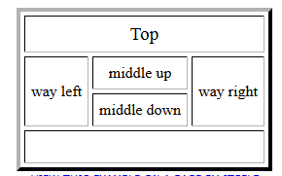

<html>

<head>

</head>

<body>

<br><br>

<table align="center" border="2" cellpadding="15" cellspacing="4">

<tr>

<th colspan="6"> Top </th>

</tr>

<tr>

<th rowspan="2"> way left </th>

<th colspan="2"> middle up </th>

<th rowspan="2"> way right </th>

</tr>

<tr>

<th colspan="2"> middle down </th>

</tr>

<tr>

<th colspan="6"> &nbsp; </th>

</tr>

</table>

</body>

</html>

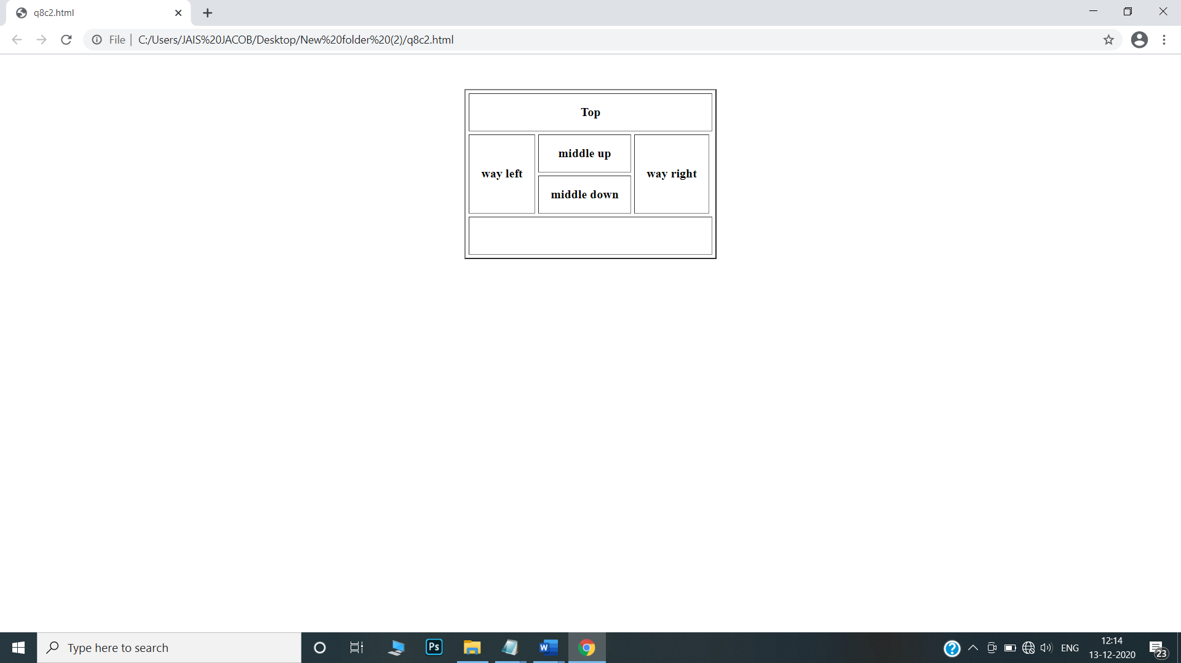

9. Make up three image links for 3 web browsers and put them in a borderless table. Construct the table so that there is just a little space between the images

<html>

<head>

</head>

<body>

<br><br>

<table align="center" style= "border-collapse : collapse;">

<tr>

<td><a href="https://www.firefox.com/" target="_blank">

<img src="D:\mozilla.jpg" alt="firefox" height="220" width="220"/>

</td>

</tr>

<tr>

<td><a href="https://www.google.com/chrome/" target="_blank">

<img src="D:\chrome.jpg" alt="chrome" height="220" width="220"/>

</td>

</tr>

<tr>

<td><a href="https://play.google.com/store/apps/details?id=com.opera.mini.native&hl=en_IN&gl=US" target="_blank">

<img src="D:\opera.jpg" alt="opera" height="220" width="220"/>

</td>

</tr>

</table>

</body>

</html>



10.Create the following html page using frames

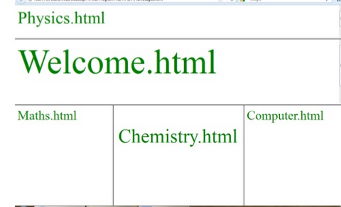

<html>

<head>

</head>

<frameset rows="20%,30%,*" border="6">

<frame src="Physics.html" name="Physics.html" />

<frame src="Welcome.html" name="Welcome.html"/>

<frameset cols="25%,50%,*" frameborder="6">

<frame src="Maths.html" name="Maths.html"/>

<frame src="Chemistry.html" name="middle down"/>

<frame src="Computer.html"name="Computer.html"/>

</frameset>

</frameset>

</html>

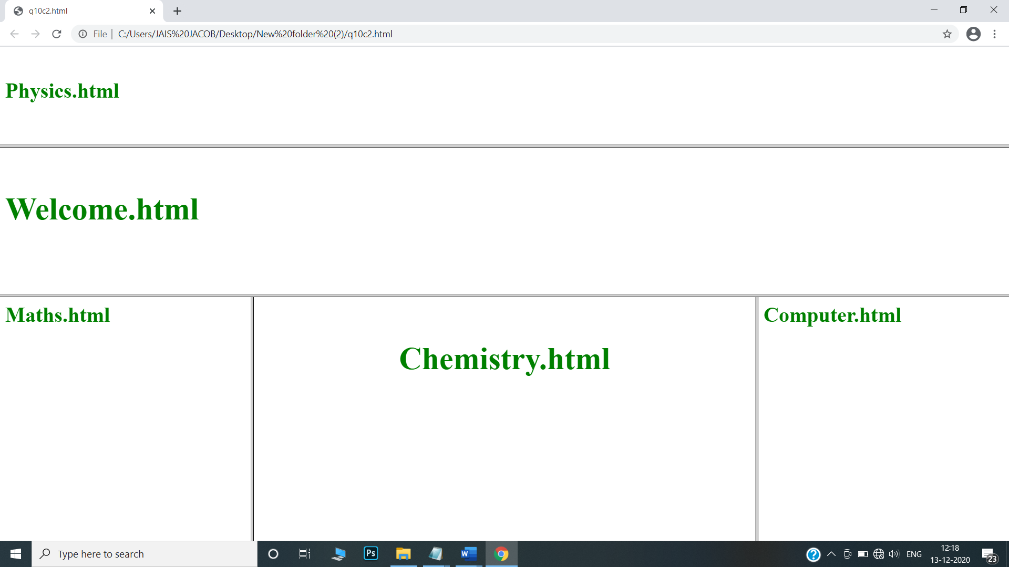

11.Create an HTML page using frames which is similar to the following one.

In the left frame provide hyperlinks to 3 important monuments in world. On clicking that hyperlink an image of the monument should be displayed in right frame with suitable description

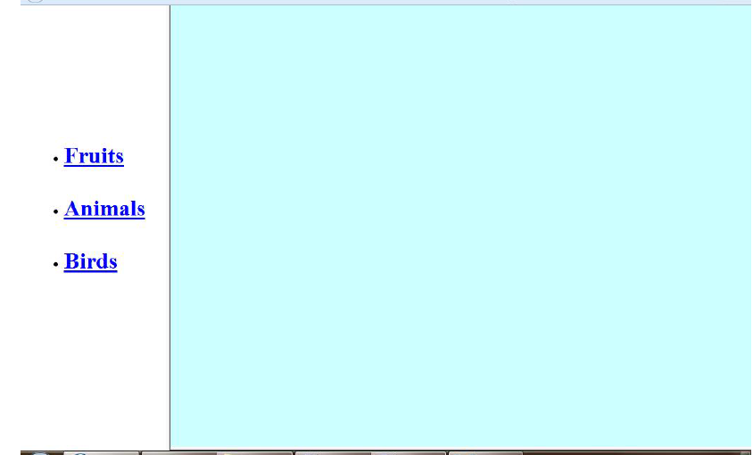

<html>

<head>

<title> navigation </title>

</head>

<frameset cols="25%,*">

<frame src="link.html"/>

<frame src="home.html"name="z"/>

</frameset>

<body>

</body>

</html>

<html>

<head>

<title> index </title>

<style>

.div_1{ background-color:blue; margin:20px; }

.div_2{ background-color:red; margin:20px; }

</style>

</head>

<body>

<center>

<br>

<div class="div_1"><h1><font color="yellow" size="6" face="Cooper">FAMOUS MONUMENTS</font></h1></div>

<div class="div_2"><font color="white" size="6" face="Cooper">

<ul>

<li>India Gate</li>

<li>Qutub Minar</li>

<li>Taj Mahal</li>

</ul>

</div>

</center>

</body>

</html>

<html>

<head>

<title> index </title>

</head>

<body>

<h1 align="center"><font face="Cooper" color="green" size="6">NAVIGATION</font></h1>

<a href="home.html" target="z">HOME</a>

<br><br>

<a href="IndiaGate.html" target="z">INDIA GATE</a>

<br><br>

<a href="QutubMinar.html" target="z">QUTUB MINAR</a>

<br><br>

<a href="TajMahal.html" target="z">TAJ MAHAL</a>

</body>

</html>

<html>

<head>

<style>

.div_1{ background-color:orange; margin:20px; }

.div_2{ background-color:yellow; margin:20px; }

</style>

</head>

<body>

<center>

<br>

<div class="div_1"><h1><font color="green" size="6" face="Cooper">INDIA GATE</font></h1></div>

<div class="div_2">

<img src="D:\indiagate.jpg" alt="INDIA GATE" height="300" width="450"/>

<p>The India Gate (originally the All India War Memorial) is a war memorial located astride the Rajpath, on the eastern edge of the "ceremonial axis" of New Delhi,[1] formal called Kingsway .It stands as a memorial to 70,000 soldiers of the British Indian Army who died in between 1914 and 1921 in the First World War, in France, Flanders, Mesopotamia, Persia, East Africa, Gallipoli and elsewhere in the Near and the Far East, and the third Anglo-Afghan War. 13,300 servicemen's names, including some soldiers and officers from the United Kingdom, are inscribed on the gate.[2] Designed by Sir Edwin Lutyens, the gate evokes the architectural style of the triumphal arch such as the Arch of Constantine, in Rome, and is often compared to the Arc de Triomphe in Paris, and the Gateway of India in Mumbai.</p>

</div>

</body>

</html>

<html>

<head>

<style>

.div_1{ background-color:orange; margin:20px; }

.div_2{ background-color:yellow; margin:20px; }

</style>

</head>

<body>

<center>

<br>

<div class="div_1"><h1><font color="green" size="6" face="Cooper">QUTUB MINAR</font></h1></div>

<div class="div_2">

<img src="D:\qutubminar.jpg" alt="QUTUB MINAR" height="300" width="450"/>

<p>The Qutb Minar, also spelled as Qutub Minar and Qutab Minar, is a minaret and "victory tower" that forms part of the Qutb complex, a UNESCO World Heritage Site in the Mehrauli area of New Delhi, India. The height of Qutb Minar is 72.5 meters, making it the tallest minaret in the world built of bricks. The tower tapers, and has a 14.3 metres (47 feet) base diameter, reducing to 2.7 metres (9 feet) at the top of the peak. It contains a spiral staircase of 379 steps.</p>

</div>

</body>

</html>

<html>

<head>

<style>

.div_1{ background-color:orange; margin:20px; }

.div_2{ background-color:yellow; margin:20px; }

</style>

</head>

<body>

<center>

<br>

<div class="div_1"><h1><font color="green" size="6" face="Cooper">TAJ MAHAL</font></h1></div>

<div class="div_2">

<img src="D:\tajmahal.jpg" alt="TAJMAHAL" height="300" width="450"/>

<p>The Taj Mahal is an ivory-white marble mausoleum on the southern bank of the river Yamuna in the Indian city of Agra. It was commissioned in 1632 by the Mughal emperor Shah Jahan (reigned from 1628 to 1658) to house the tomb of his favourite wife, Mumtaz Mahal; it also houses the tomb of Shah Jahan himself. The tomb is the centrepiece of a 17-hectare (42-acre) complex, which includes a mosque and a guest house, and is set in formal gardens bounded on three sides by a crenellated wall.</p>

<p>Construction of the mausoleum was essentially completed in 1643, but work continued on other phases of the project for another 10 years. The Taj Mahal complex is believed to have been completed in its entirety in 1653 at a cost estimated at the time to be around 32 million rupees, which in 2020 would be approximately 70 billion rupees (about U.S. $916 million). The construction project employed some 20,000 artisans under the guidance of a board of architects led by the court architect to the emperor, Ustad Ahmad Lahauri.</p>

</div>

</body>

</html>

